Goal: To create a program which allows me to add payments I’ve made to a database of all of my payments. I need to know what day I made the payment, what type of payment it was, and add notes to remind myself of things about the payment. I then want to see a graph laying out my payment stats of the selected type over the selected pay period (eventually with custom date range as an option). Would like ability to view and edit specific payment details in own panel or popup.

MVP: Create new payments or remove existing payments which contain basic payment data to left panel. View numeric statistics in bottom of middle panel based on selected payment types and date range in right panel. Selecting a type or date range refreshes numbers. Adding a new payment opens a new popup panel to create basic data. Closing this popup cancels the creation process. Valid numeric amounts are validated and formatted, dates are validated and formatted, new payment types are added to list if submitted payment type does not exist with a prompt confirming creation of new payment type.

1. Payments and Payment Creation
2. Statistics
3. Event Tag and Date Range selection
4. Stretch - Graphing

**1. 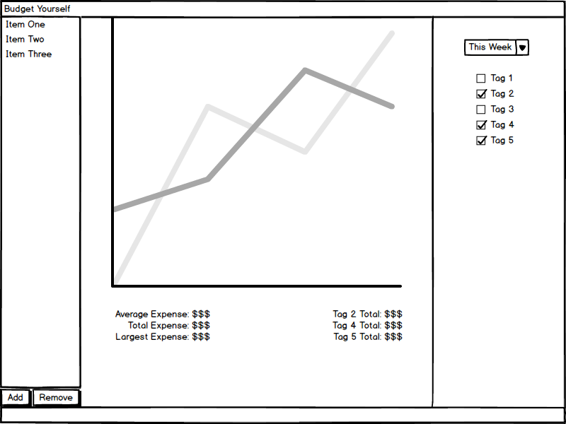Payments and Payment Creation**

On the left in the mockup above, a list of existing payment objects can be seen. The at-a-glance view only shows the payment name. Fields expected to be involved in payment object creation:

* Payment Name
* Payment Amount
* Payment Date
* Created Date
* Payment Type
* Payment Note

Clicking the add button will open a new panel or popup to create a brand new payment and add it to the list of existing payments. Clicking remove will check for the selected payment (if any) and remove it from the list.

**2. Statistics Section**

In the bottom-center of the mockup above, a list of payment statistics can be seen. The statistics displayed on the left are pre-determined and fairly basic (average, total, largest) and are applied to all selected payment types over the selected date range. The statistics on the left are a breakdown of the selected payment types individually. Are added dynamically as payment types are added. Could make this a scrolling panel to accommodate its dynamic nature. Might include average/total/max for each individual payment type over the selected payment period.

**3. Event Tag and Date Range Selection**

In the right panel of the mockup above, there is a Combo Box for selecting the date range. The end-goal is to have a nice calendar date range picker, but for MVP a pre-constructed combo box is sufficient. The selections will choose the correct date ranges from which to pull the payments from the payment history. The user can turn on/off which payment types the user wants to see in the statistics section using a JCheckBox scrolling panel. Picking a new date range or enable/disabling a payment type will cause the statistics to refresh automatically.

**4. Graphing**

I have not yet looked into graphing at all in Swing. Goal is to figure out how graphing works and learn how to create reasonable intervals to display over the selected Date Range. For example, a single-day graph might be a bar graph of the different payment types compared to the total, whereas a wider range would be a line graph with reasonable intervals (days, weeks, months).